**DDL Aggregators and Nested Queries**

**DOG SALON**

1. List of all services and the products used for a dog

1. Average cost of all services provided to a dog

1. Sum total of cost for all services provided to all dogs, sorted by highest to lowest

1. Sum total of costs for all services provided by each employee, between two dates, sorted from highest to lowest

5.Average of cost for all services provided for each dog by each employee, sorted from highest to lowest

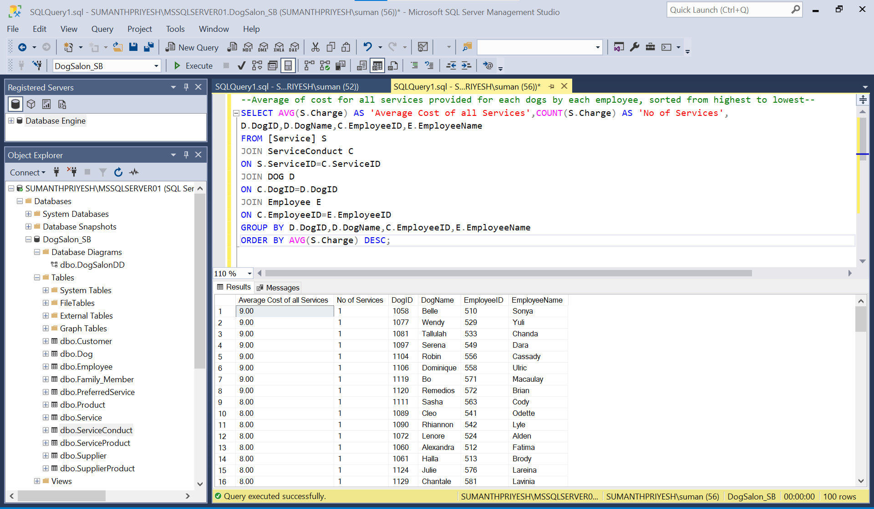

1. Average cost for all preferred services for each dog, sorted from highest to lowest

